**Assignment – 1 Power BI**

Report View

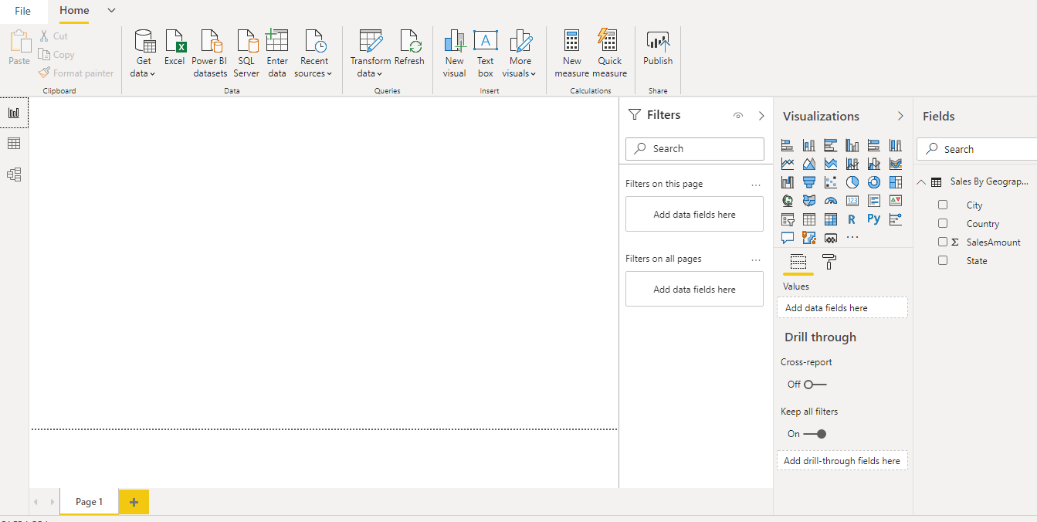

Data View

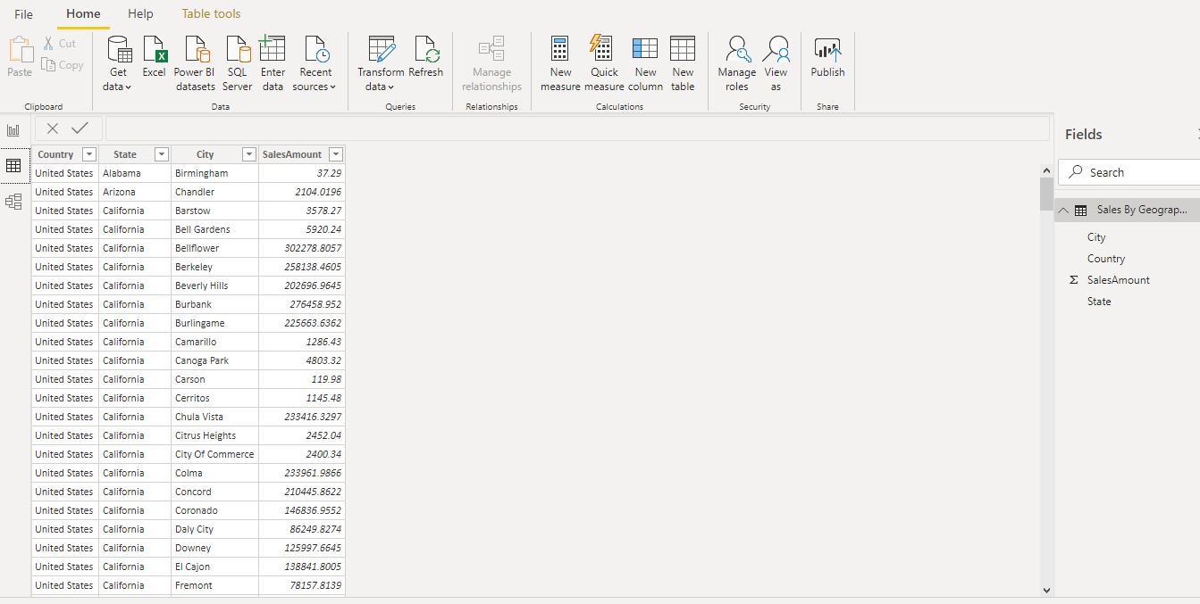

Model View

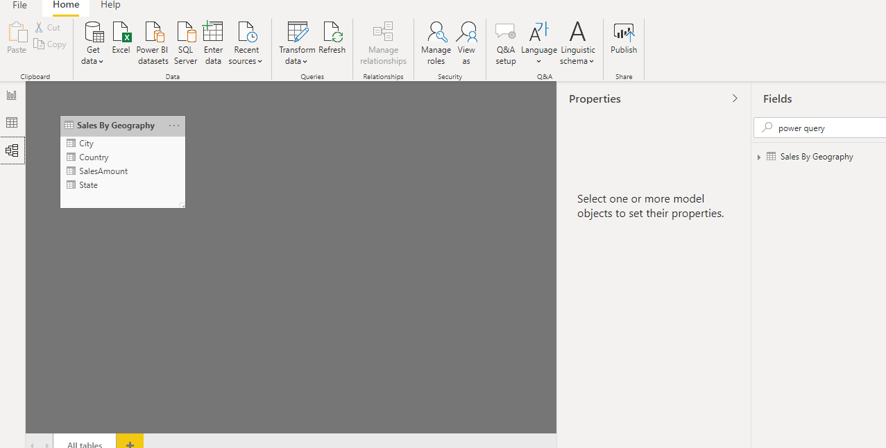

Power Query Editor

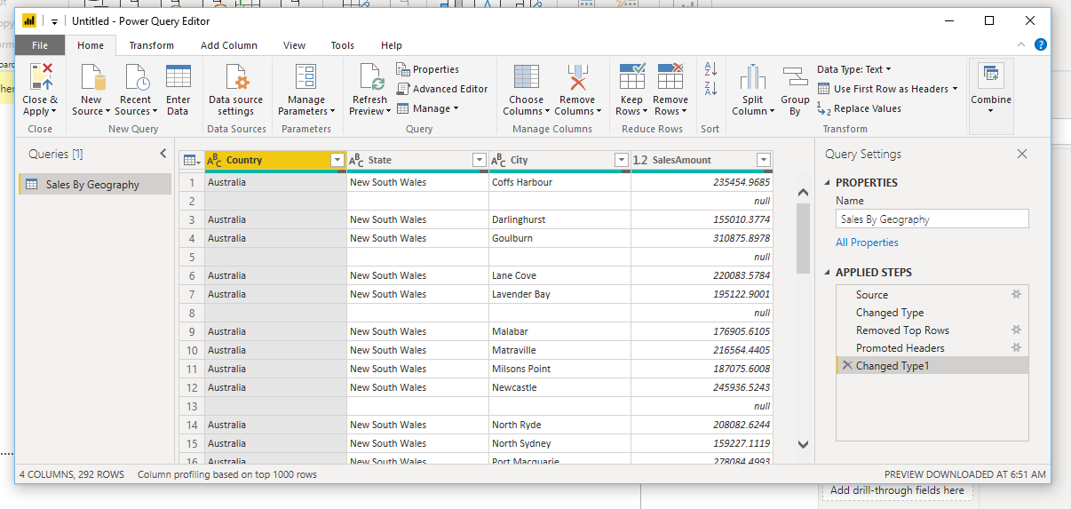

Advance Editor

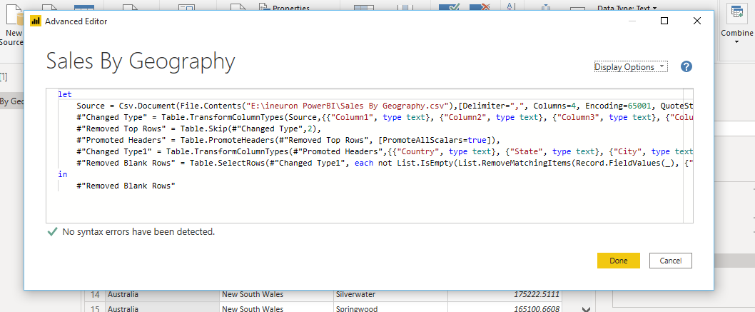

**Power BI Desktop**

* Create rich, interactive reports with visual analytics at your fingertips
* Price: 60 day trial

**Power BI Pro**

* Self Service and modern BI in cloud
* Collaboration, publishing, sharing, and ad hoc analysis
* Fully managed by Microsoft.
* Price: $9.99 monthly price per user

**Power BI Premium**

* Enterprise BI, Big data analytics, cloud and on-premises reporting
* Advanced administration and deployment controls
* Dedicated cloud compute and storage resources
* Allows any user to consume Power BI Content
* Price: $4995 Monthly price per dedicated cloud compute and storage resource with annual subscription.